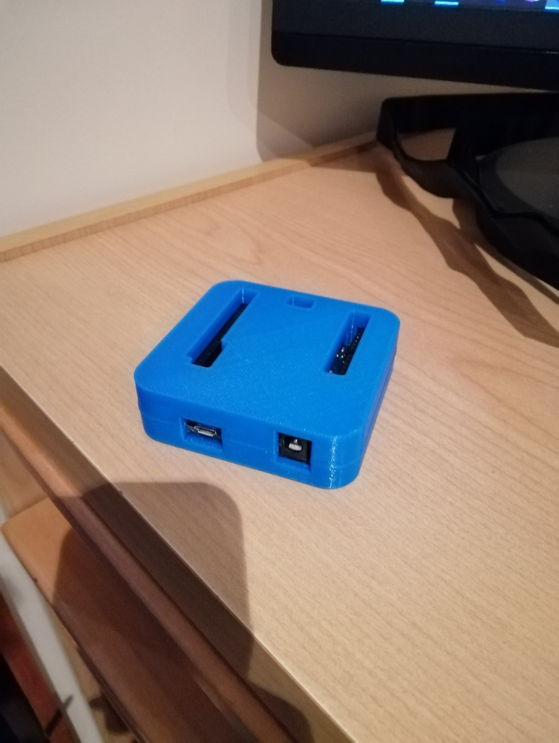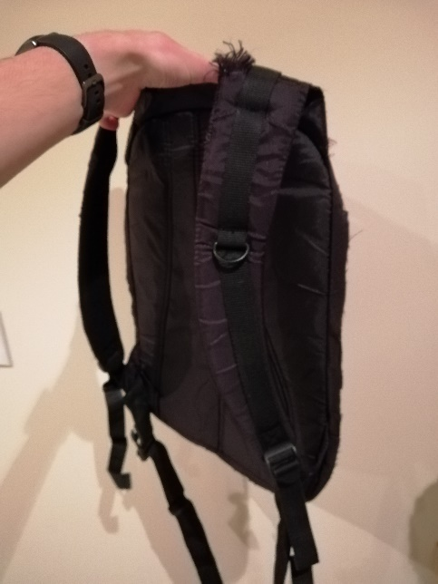**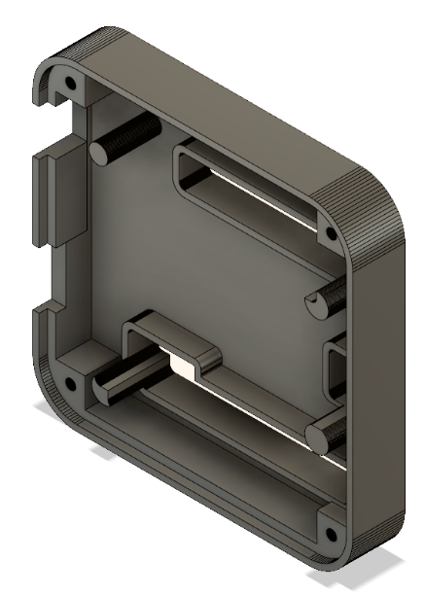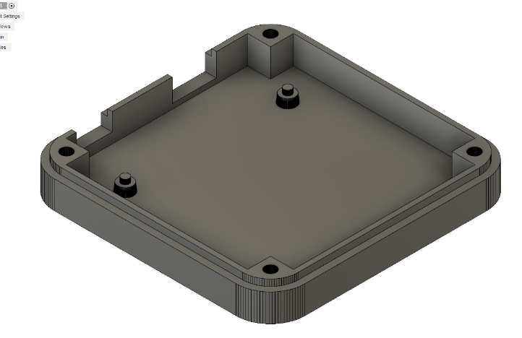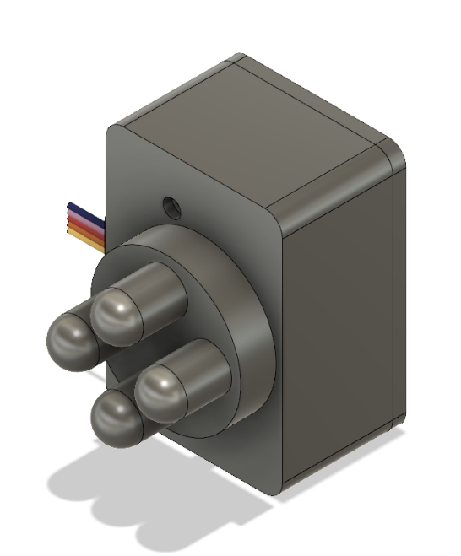Sprint 2**

Body Mount (Modified Backpack), will be further modified later in development to allow access to have an open back region

Constructed Housing

3D Modelled Designs of Housing

3D Modelled Design of Head

|  |  |  |  |  |  |  |
| --- | --- | --- | --- | --- | --- | --- |
| Type of test | What is being tested? | Expected result | Actual result | Action taken (if any) | Evidence | Notes |
| Expected | Under control of a test code, the head’s gyration should be controlled | Head gyration can be turned on and off on command |  |  |  | Postponed for next sprint as the related task was substituted out |
| Expected | The access of the Arduino board’s pins through the housing | Pins should be reachable by jumper cables through the holes in the housing | All pins I could foresee using are accessible |  |  |  |
| Expected | The micro USB port of the Arduino board’s accessibility through the housing | The housing should not obstruct the cable from reaching the port | No obstruction |  |  |  |